Andhra Pradesh
- State Maps
- State Profile
- Health Profile
- Organogram
- List & addresses of State Officials
- State Plan Approval 2007-08
- State Plan Approval 2008-09
- State PIP's for 2007-08
- State PIP's for 2008-09
- State website
- District Health Action Plan
- Notification & Resolution
- Rogi Kalyan Samiti at District Hospital with account number
- Presentation of State Plan, 2008-09
- 24x7 Facilities
- Integrated Bank Account of State Health Society
- State Nodal Officer
- Statewise NRHM Progress - A Snapshot
- Facility Survey Report
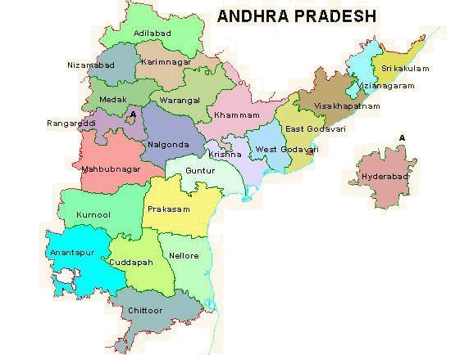
PROFILE OF THE ANDHRA PRADESH
Geography
Andhra Pradesh lies between 12º41' and 22º longitude and 77º and 84º40' latitude. It is bounded by Madhya Pradesh and Orissa in the north, the Bay of Bengal in the east, Tamil Nadu and Karnataka in the south and Maharashtra in the west. Andhra Pradesh is the fifth largest state in India and it forms the major link between the north and the south of India. It is the biggest and most populous state in the south of India.
There are three main regions in Andhra Pradesh - (1) Northern Circars or coastal Andhra comprising Srikakulam, Visakhapatnam, East Godavari, West Godavari, Krishna, Guntur, Ongole and Nellore districts; (2) Rayalaseema or Ceded districts comprising Kurnool, Cuddapah, Chittoor and Anantapur districts; and (3) Telangana comprising Khammam, Nalgonda, Warangal, Karimnagar, Medak, Nizamabad, Aadilabad, Mahbubnagar and Hyderabad districts. The Circars or Coastal districts are well developed and enjoy a greater degree of affluence than the other two regions; Rayalaseema is close to the coastal districts and here rainfall is less than in the coastal districts and drought conditions prevail sometimes, and the Telangana region is of the former princely state of Nizam's Hyderabad, which is close to Maharashtra's Marathwada region and some parts of Karnataka.
The state is dotted with hill ranges from the north to the south, running erratically down the middle of the country dividing it into western and eastern or coastal Andhra. These hills form integral geographical entities of Andhra life and history. In the north, there are Simhachalam and Annavaram hills, in the middle country there are the Srisailam hill ranges and in the south are the Tirumalai-Tirupati hills. The state has two great rivers, Godavari and Krishna which spring from the Western Ghats in Maharashtra and flow eastward and joins the Bay of Bengal. The Godavari enters the state of Andhra Pradesh direct from Maharashtra, but the Krishna first goes to Karnataka where it flows for a considerable distance before entering Andhra Pradesh. Besides these two big rivers, there are the Tungabhadra, the Pennar and many other small rivers and rivulets. Pennar originates in the Karnataka plateau. Like all the peninsular rivers and even those which arise in central India, like the Narmada, Sone and Chambal, all these are rain fed rivers as there is no snow below the Himalayas. Andhra Pradesh has considerable topographical variations with dense forest in the north east, flat paddy lands in the coastal plains, several noteworthy beaches along the Bay of Bengal and the stark boulder-strewn region around Hyderabad.

History
Andhra Pradesh is said to have been the home of the Pre- Dravidian dark coloured inhabitants. Andhra region witnessed the rule of Chandragupta Maurya during which it established itself as an independent kingdom. After Ashoka, the Mauryan empire declined giving opportunity to establish smaller kingdoms. In about the third century BC the Satavahanas ruled for about five centuries. The Satavahanas established a strong rule with their territories extending upto Maharashtra and Madhya Pradesh. The Satavahanas were overpowered by the Ikshvakus by the third century AD. During this period Brahmanism is said to have been revived. This reduced the influence of Buddhism which was fostered by the Satavahanas.
By the end of the third century AD the Pallavas of Kanchi put an end to the rule of the Ikshavakus. Art and Architecture advanced during their rule. By 4th century AD the Anandas established their rule which lasted till 6th century. During the 7th century the Eastern Chalukyas exercised their power for many centuries. Literature was advanced during this period with promotion of the Telegu script. The Kakatiyas who were the feudatories of the Eastern Chalukyas became independent in about the 12th century. During the rule of Delhi Sultanate, Muslims repeatedly attempted to invade Andhra. In 1332 AD Ulugh Khan established the Reddi Kingdom of Kondavidu; the Velama kingdom. The Vijayanagar Kingdom also ruled independently . The rule of Muhammad Tughlag witnessed the rise of the independent Muslim Power at Bijapur. This was under the Bahamani Sultanate. In 1518 the Sultan Qili Qutub Shah declared himself independent and founded the Qutub Shah dynasty which existed till 1687. During this period literature, art and architect advanced. The city of Hyderabad was laid in 1591 by Muhammad Quli Qutub Shah. The Mughals put an end to the Qutub Shahi rule in 1687. After this the Asafjahis called Nizams emerged. They influenced Andhra Pradesh throughout the 18th century till Andhra Pradesh was ceded to the East India Company. Gradually the whole of Andhra Pradesh except Hyderabad was under the British till 1947. In 1956 Andhra Pradesh was declared as a state.
The state of Andhra Pradesh has an area of 275,045 sq. km. and a population of 76.21 million. There are 23 districts, 1128 blocks and 28123 villages. The State has population density of 277 per sq. km. (as against the national average of 312). The decadal growth rate of the state is 14.59% (against 21.54% for the country) and the population of the state is growing at a slower rate than the national rate.
<<< go to TOP
HEALTH INDICATORS OF ANDHRA PRADESH
The Total Fertility Rate of the State is 1.8. The Infant Mortality Rate is 52 and Maternal Mortality Ratio is 154 (SRS 2004 - 06) which are lower than the National average. The Sex Ratio in the State is 978 (as compared to 933 for the country). Comparative figures of major health and demographic indicators are as follows:
Table I: Demographic, Socio-economic and Health profile of Assam State as compared to India figures
S. No. | Item | Andhra Pradesh | India
1 | Total population (Census 2001) (in million) | 76.21 | 1028.61
2 | Decadal Growth (Census 2001) (%) | 14.59 | 21.54
3 | Crude Birth Rate (SRS 2008) | 18.4 | 22.8
4 | Crude Death Rate (SRS 2008) | 7.5 | 7.4
5 | Total Fertility Rate (SRS 2008) | 1.8 | 2.6
6 | Infant Mortality Rate (SRS 2008) | 52 | 53
7 | Maternal Mortality Ratio (SRS 2004 - 2006) | 154 | 254
8 | Sex Ratio (Census 2001) | 978 | 933
9 | Population below Poverty line (%) | 15.77 | 26.10
10 | Schedule Caste population (in million) | 12.34 | 166.64
11 | Schedule Tribe population (in million) | 5.02 | 84.33
12 | Female Literacy Rate (Census 2001) (%) | 50.4 | 53.7
Table II: Health Infrastructure of Andhra Pradesh
Particulars | Required | In position | shortfall
Sub-centre | 11699 | 12522 | -
Primary Health Centre | 1924 | 1570 | 354
Community Health Centre | 481 | 167 | 314
Multipurpose worker (Female)/ANM at Sub Centres & PHCs | 14092 | 12541 | 1551
Health Worker (Male) MPW(M) at Sub Centres | 12522 | 6127 | 6395
Health Assistants (Female)/LHV at PHCs | 1570 | 1564 | 6
Health Assistants (Male) at PHCs | 1570 | 1920 | -
Doctor at PHCs | 1570 | 2214 | -
Obstetricians & Gynaecologists at CHCs | 167 | 95 | 72
Physicians at CHCs | 167 | 20 | 147
Paediatricians at CHCs | 167 | 90 | 77
Total specialists at CHCs | 668 | 235 | 433
Radiographers | 167 | 65 | 102
Pharmacist | 1737 | 1614 | 123
Laboratory Technicians | 1737 | 1363 | 374
Nurse/Midwife | 2739 | 2373 | 366
(Source: RHS Bulletin, March 2008, M/O Health & F.W., GOI)
The other Health Institution in the State are detailed as under:
Health Institution | Number
Medical College | 32
District Hospitals | 16
Referral Hospitals
City Family Welfare Centre
Rural Dispensaries
Ayurvedic Hospitals | 9
Ayurvedic Dispensaries | 557
Unani Hospitals | 6
Unani Dispensaries | 196
Homeopathic Hospitals | 6
Homeopathic Dispensary | 286

<<< go to TOP
Organogram

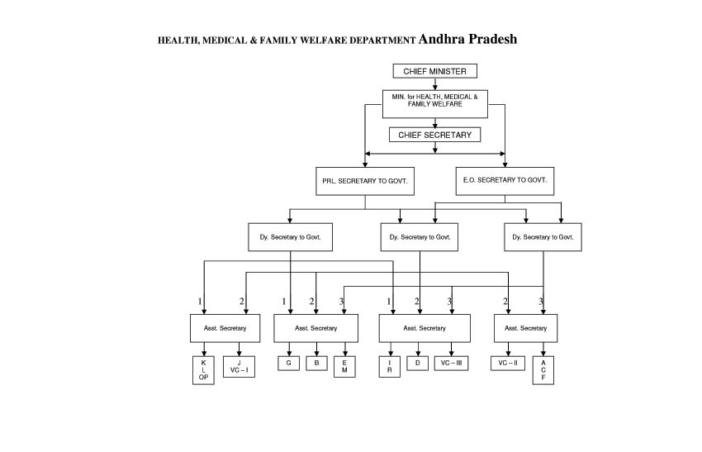
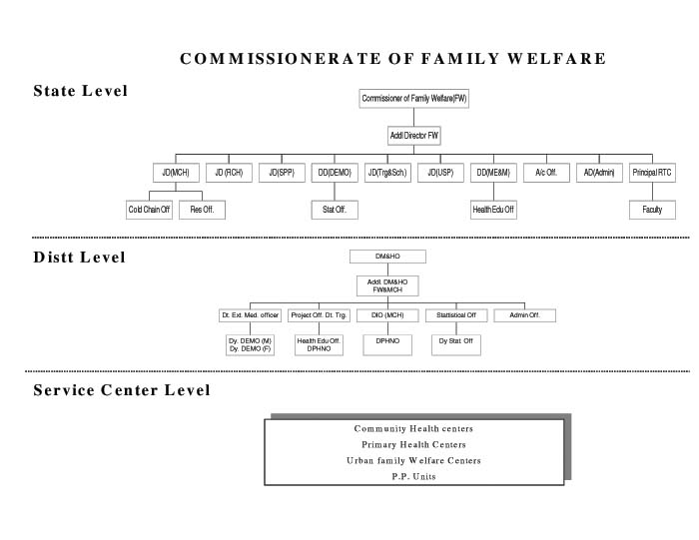
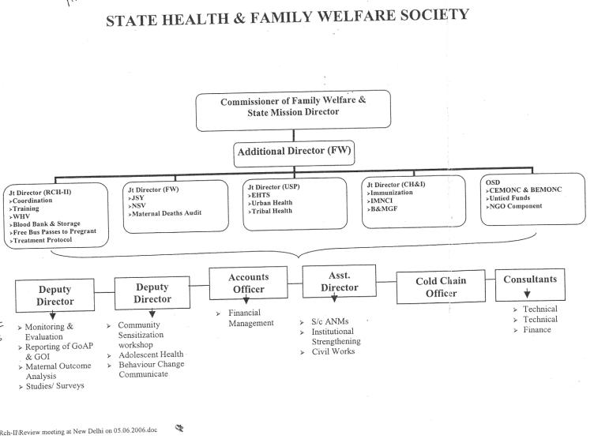

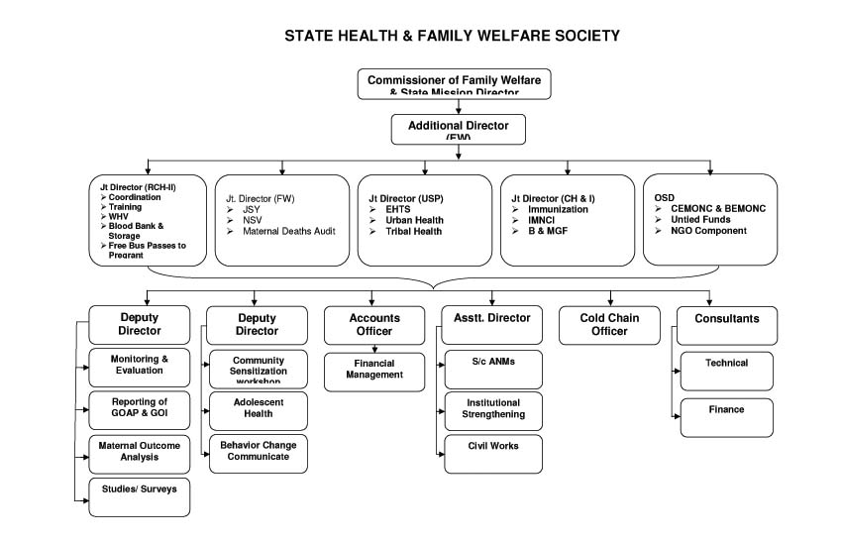
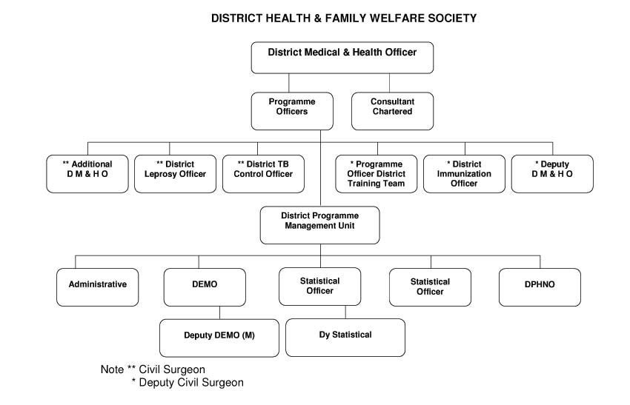
List and Addresses of State Officials

Principal Secy
Sh. P.V. Ramesh,
Principal Secretary,
Health Medical and Family Welfare Deptt.,
Government of Andhra Pradesh, 3rd floor,
L - Block, AP Secretariat,
Hyderabad- 500029. Andhra Pradesh
Tel.(Off): +91-40-23455824 , Fax: +91-40-23457817, Mob: +91-9866551230
E-Mail: prlsecy_hmfw@ap.gov.in, secy-hfw-ap@nic.in
Mission Director
Sh. Anil Chandra Punetha,
Mission Director-cum-commssioner of Family Welfare &
EO Principle Secretary, Secretary to Govt.,
Health Medical and Family Welfare Deptt.
Government of Andhra Pradesh
Deptt. DM & HS Campus, Sultan Bazar, Hyderabad- 500095.

Tel.(Off): +91-40-24650365, +91-40-24653771, Fax: +91-40-24652267, Mob: +91-9848844388
E-Mail: cfwhyd@yahoo.com, md-ap-nrhm@nic.in
Regional Director
Dr. K. Ramiah
Sr. Regional Director,
Regional Office for Health & Family Welfare,
Govt. of India,
III Floor, B Block, Kendiya Sadan,
Sultan Bazar,
Hydrabad-500095
Telefax: 91-40-24657923, Mob.: +91-9441058234
Email: hyd.2jayak195@savehar.net.in
Director in Chief / Director Health Services
Dr. Ram Swaroop,
Director of Health,
DM&HS Campur
Koti, Hyderabad
Tel. (Off): +91-40-24656988
Mob: +91-9849902201
Email: dir_health@ap.gov.in, dir_health@yahoo.co.in
NRHM Nodal Officer
Smt. Rama Mani,
DM&HS Campur
Koti, Hyderabad
Mob: +91-8008889155
State Programme Manager
Smt. Rama Mani,
DM&HS Campur
Koti, Hyderabad
Mob: +91-8008889155
State Finance Manager
Smt. Balatripura Sundari,
DM&HS Campur
Koti, Hyderabad
State Data Officer
Sh. K. Laxman Das,
DM&HS Campur
Koti, Hyderabad
Mob: +91-9618001445, +91-9908392225
State Immunisation Officer
Dr. R. Gopal Krishna Rao,
Joint Director (MCH) and State EPI Officer, O/o Commissioner Family Welfare,
Sulatan Bazar, Hyderabad-500095
+91-40-24651063(TF), +91-40-24606378(T),
State IEC Officers
Sh. A. Ramachadanaran,
Deputy Director (Mass Media),
Commissioner of Family Welfare,
Govt. of Andhra Pradesh, Sultan Bazar, Koti, Hyderabad
+91-40-24606379(o), +91-989902239 (m), +91-40-27248577(res)
State RCH Officers
Dr. M.S. Srinivas Rao,
Joint Director (RCH-II),
Government of Andhra Pradesh, Hyderabad
Email: jdrchs@gmail.com
Disease Control Programs
1. NPCB  (National Programme for Control of Blindness) | Dr. Ram Swaroop,  Director of Health,  DM&HS Campur  Koti, Hyderabad  Tel. (Off): +91-40-24656988  Mob: +91-9849902201  Email: dir_health@ap.gov.in, dir_health@yahoo.co.in
2.NLEP  (National Leprosy Eradication Programme) | Dr. Ram Swaroop,  Director of Health,  DM&HS Campur  Koti, Hyderabad  Tel. (Off): +91-40-24656988  Mob: +91-9849902201  Email: dir_health@ap.gov.in, dir_health@yahoo.co.in
3.RNTCP (Revised National Tuberculosis Control Programme) | Dr. Ram Swaroop,  Director of Health,  DM&HS Campur  Koti, Hyderabad  Tel. (Off): +91-40-24656988  Mob: +91-9849902201  Email: dir_health@ap.gov.in, dir_health@yahoo.co.in
4.IDSP  (Integrated Disease Survlliance Programme) | Dr. Ram Swaroop,  Director of Health,  DM&HS Campur  Koti, Hyderabad  Tel. (Off): +91-40-24656988  Mob: +91-9849902201  Email: dir_health@ap.gov.in, dir_health@yahoo.co.in
5. NIDDCP  (National Iodine Deficiency Disorders Control Programme) | Dr. Ram Swaroop,  Director of Health,  DM&HS Campur  Koti, Hyderabad  Tel. (Off): +91-40-24656988  Mob: +91-9849902201  Email: dir_health@ap.gov.in, dir_health@yahoo.co.in
6.NVBDCP  (National Vector Borne Disease Control Programme) | Dr. Ram Swaroop,  Director of Health,  DM&HS Campur  Koti, Hyderabad  Tel. (Off): +91-40-24656988  Mob: +91-9849902201  Email: dir_health@ap.gov.in, dir_health@yahoo.co.in

